SHEAR STRENGTH THEORY
Soil Strength and its Importance
The shear strength of a soil is its maximum resistance to shear under any given conditions. Its value determines such factors as the stability of the slope, the allowable bearing capacity of a foundation and the thrust of a soil against a retaining wall. The drainage conditions of the soil at the time of loading determine the magnitude of the shear strength. The knowledge of the shear strength is an essential prerequisite to any analysis concerned with the stability of the soil mass.

Coulomb Failure Equation
The equation of the Coulomb soil failure analysis is given as:

$$τ=C+ σ tanφ$$

where, $τ$ = maximum resistance to shear
$σ$= total compressive stress normal to the failure plane
$C$ = soil cohesion
$φ$= angle of internal friction or shearing resistance of the soil

For granular soils which are cohesionless, $C=0$ and$τ=σ tanφ$.

The use of the Coulomb equation did not always result in the successful design of soil structures. The reason for this did not become apparent until the concept of the principle of effective stress was published by Terzaghi. It was then realized that since water cannot sustain shear stress, the shear resistance of the soil must result solely from the frictional resistance acting at the particle contact point; the magnitude of which depends solely on the magnitude of effective stress carried by soil particles alone., Thus the greater the effective stress normal to a potential failure plane, the greater the resistance to shear on the plane. In terms of effective stress, the Coulomb equation can be re-written as:

$$τ=C'+ σ' tanφ'$$

where, $τ$ = maximum resistance to shear
$σ'$= effective total compressive stress normal to the failure plane
$C'$ = effective soil cohesion
$φ'$= effective angle of internal friction or shearing resistance of the soil

Since the shear strength is controlled by the effective stresses in the soil then fundamentally a stability analysis should be carried out in terms of effective stress. In certain circumstances, the analysis may be in terms of total stress and therefore in general will require determining both the effective stress and the total stress of the soil. These soil parameters can be determined using either the direct shear test or the triaxial compression test.

Direct shear test: This consists of a soil sample contained in a box split horizontally in two halves. A normal force N is applied to the sample through the top loading plate and by constraining the upper half of the box, the sample is sheared on the horizontal plane by the application of a shear force S. The vertical movement of the sample during shearing is measured by means of a dial-gauge resting on top of the plate. The soil sample could be completely undrained, partially drained or completely drained at the time of conducting the test. The shear stress becomes $τ=S/A$ and the normal stress $σ=N/A.$

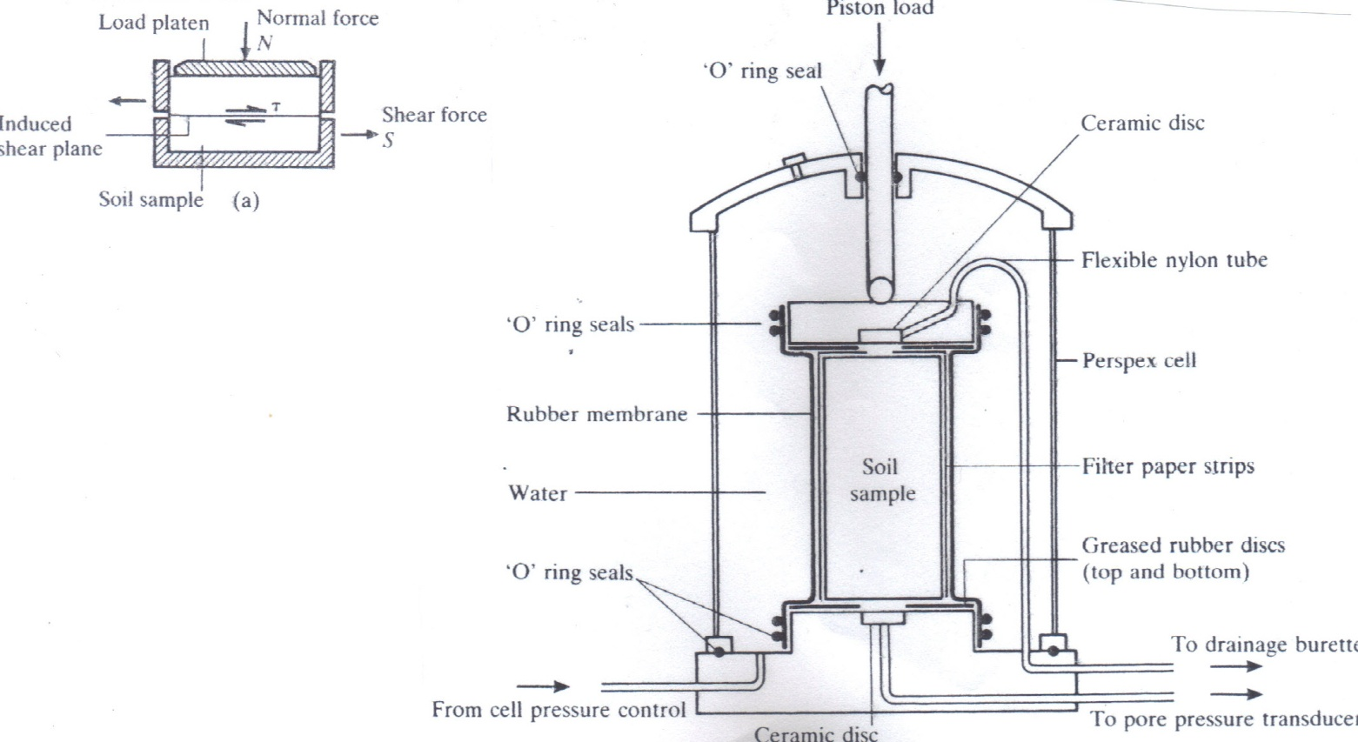

Figure 1. Direct shear box test Figure 2. Triaxial compression test

Triaxial compression test: The triaxial test is the most common method used in soil mechanics laboratory for finding shear strength of the soil. The soil specimen is extruded from a 37.5 mm diameter cutting tube, capped top and bottom and covered with a rubber membrane to prevent loss of water. The prepared sample is placed in position and the transparent cylinder in which the sample is placed filled with water. A measured pressure head is applied to the water which surrounds the sample inducing a lateral pressure on the sample known as the cell pressure. The cell pressure is referred to as the minimum principal stress (𝜌₃). A vertical load is now applied to the sample at a constant rate of strain until the sample fails by shearing. This vertical applied pressure at failure which is known as the deviator stress is added to the cell pressure to give the maximum principal stress (𝜌₁). With the maximum and minimum stresses at the point of failure, a Mohr circle can be drawn where the radius of the circle is given as R = (𝜌₁ - 𝜌₃)/2 and the centre of the circle located at (𝜌₁ + 𝜌₃)/2 on the normal stress axis. If a series of tests are carried out with different cell pressures, a series of Mohr circles may be drawn which will have a common tangent known as the Mohr envelop. This line gives the Coulomb failure equation. The soil sample could be completely undrained, partially drained or completely drained at the time of conducting the test. It could also be confined or unconfined. For unconfined compression tests, the sample is sheared rapidly, no drainage takes place, the lateral pressure is zero and the angle of internal soil friction could also be assumed to be zero.

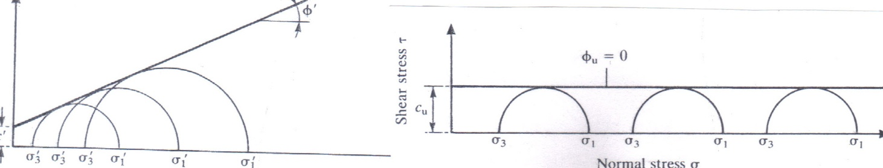

Figure 3. Mohr envelop (confined test) Figure 4. Mohr envelop (unconfined test)

The Mohr Circle and the Rankine’s theory
From the geometry of the Mohr circle, it can be shown that, for passive earth pressure on cohesive soils:

$ρ_{1}= ρ_{3}N_{φ}+ 2C\sqrt{N_{φ}}$

where, $ρ_{1}$ = maximum principal stress
$ρ_{3}$= minimum principal stress
$C$ = soil cohesion
$N_{φ}$=$\tan^{2}\left(45+φ/2\right)$; $φ$ = angle of internal friction or shearing resistance of the soil

Assuming a vertical wall and horizontal soil surface, if the vertical pressure is weight of cohesionless soil above any depth z is γz = $ρ_{3}$ and the horizontal pressure is the passive pressure at failure, P_{p} = $ρ_{1}$,

$P_{p}= γzk_{p}$

Where, $k_{p}$= $N_{φ}$= $\tan^{2}\left(45+φ/2\right)$ = coefficient of passive earth pressure

The Bell’s solution for passive resistance of cohesive soils on retaining wall is given as:

$$P_{p}= γzk_{p} + 2C\sqrt{k_{p}}$$

This suggests that cohesion increases the value of passive resistance. In soil tillage operations, soil failure in front of very wide tines blades can be reduced to a 2-dimensional problem and likened to an infinitely long retaining wall and retaining wall failure theory can be used in this analysis. This problem is dealt with in more detail under soil engaging implements.

Problems
- A series of undrained triaxial tests on samples of saturated soil gave the following results:

Lateral pressure (kN/m²) | 100 | 200 | 300
Pore water pressure (kN/m²) | 20 | 70 | 136
Principal stress difference at failure (kN/m²) | 290 | 400 | 534

Find the values of the parameters C and $φ$:
- with respect to total stress
- with respect to effective stress

- The following results were obtained from undrained shear box tests on samples of silty clay:

Normal pressure (kN/m²) | 100 | 200 | 300
Shear strength (kN/m²) | 20 | 70 | 136

Find the apparent cohesion and the angle of shearing resistance. Find also the value of the apparent cohesion which would be expected from an unconfined compression test on a sample of the same soil. If another specimen of this soil is subjected to an undrained triaxial compression test with lateral pressure 280 kN/m², find the total axial pressure at which failure would be expected.

